1. You are given these two points (x1=2, y1= -3). (x2=a, y2=b)
2. What is the slope of the line that passes through these two points?

b+3

___ or (b+3)/(a-2)

a-2

1. What is the equation of the line that passes through the two point?

y = ((b+3)/(a-2))x - 3 - (2b+6)/(a-2)

1. What is the equation of the line that passes through point (x=c and y=d) and has an angle of $θ$ degrees with the x axis, show your detail work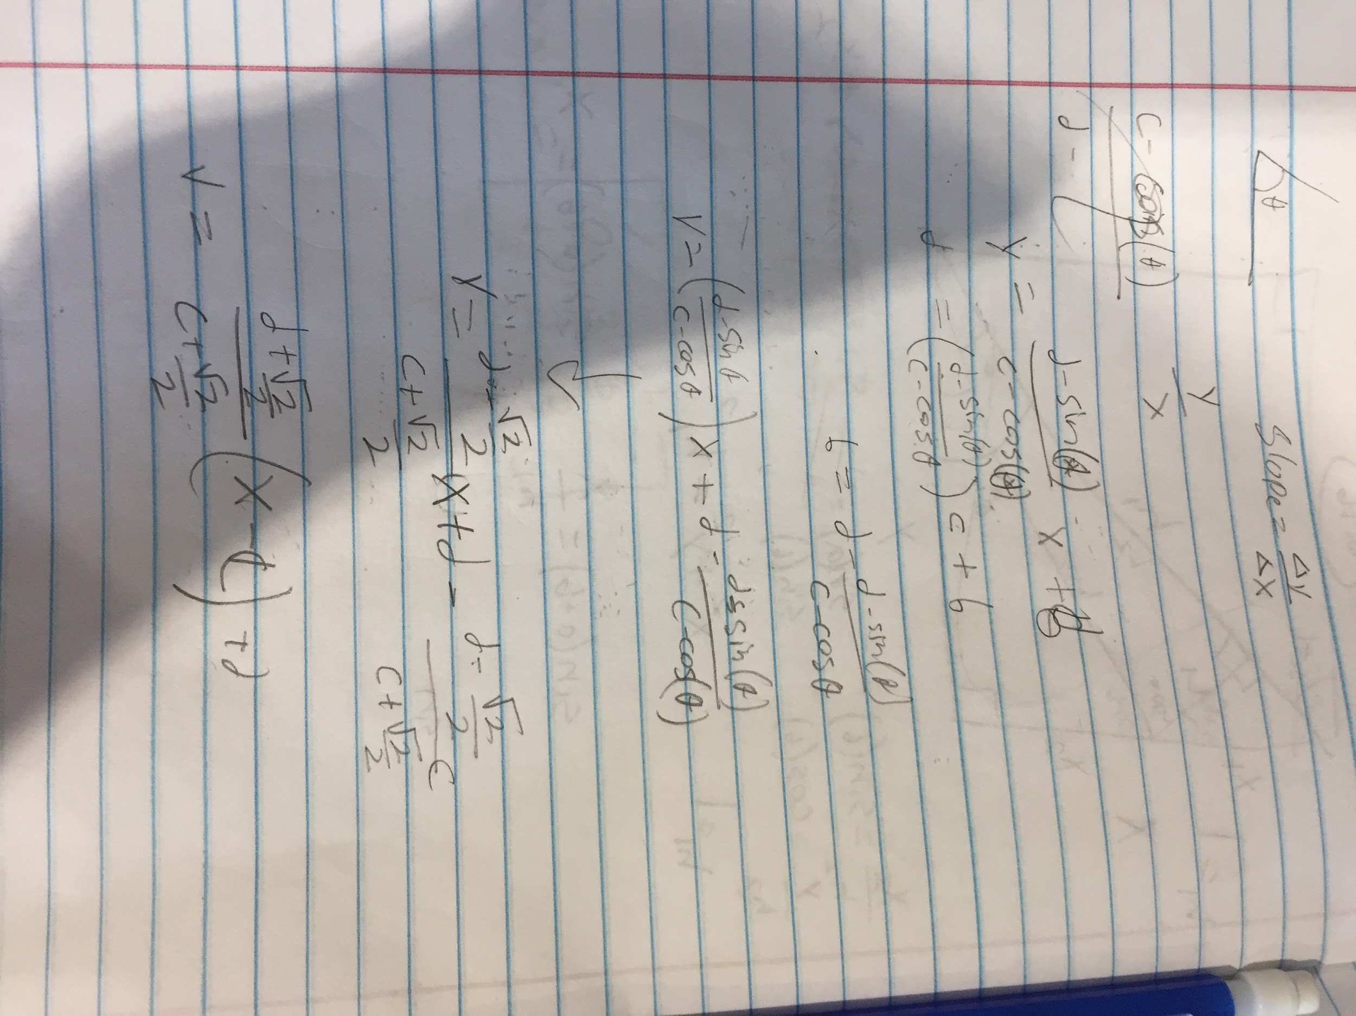
2. What is the equation of the line that passes through (x=c and y=d) and has an angle of 135 with the x axis?